[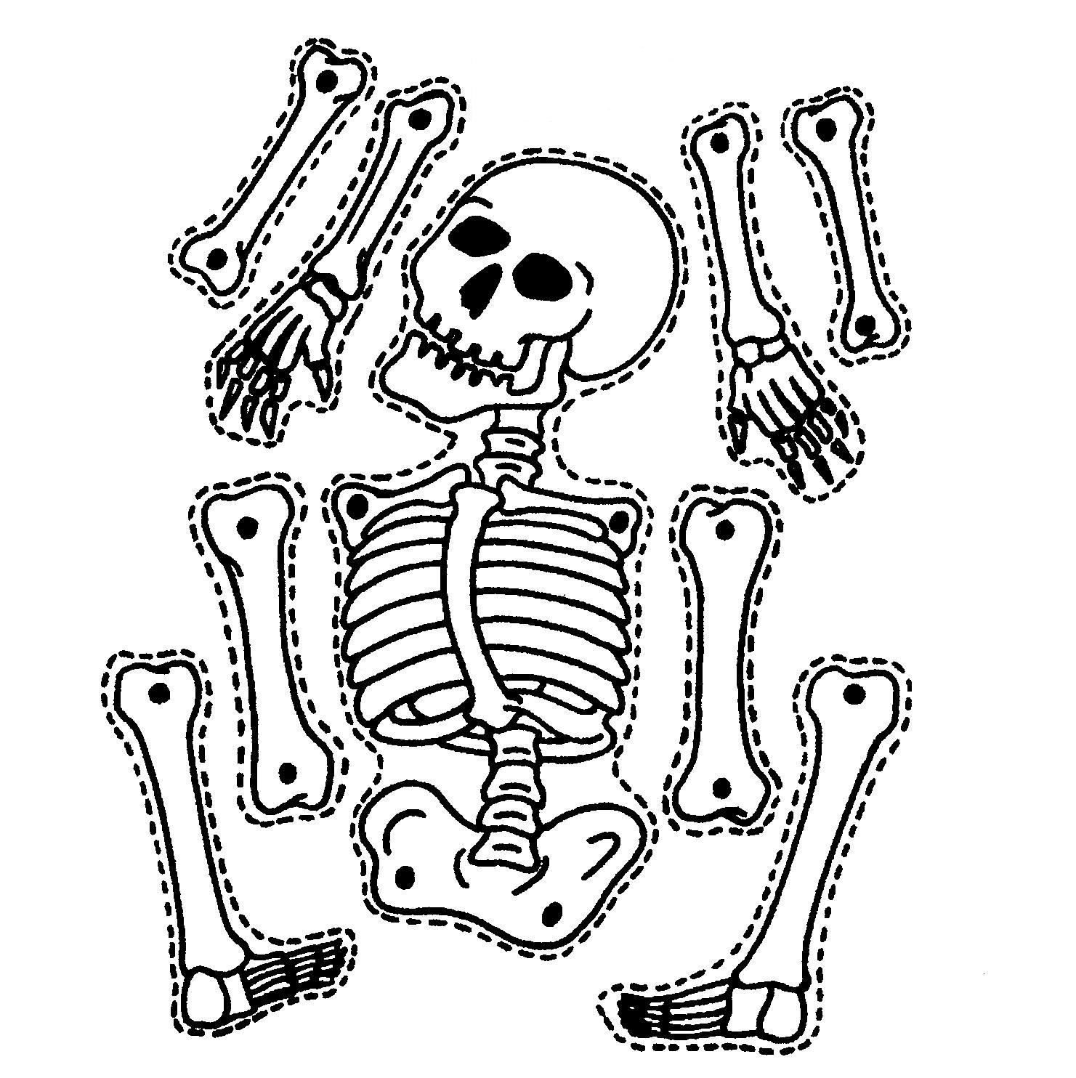](http://www.google.com/url?sa=i&rct=j&q=&esrc=s&source=images&cd=&cad=rja&uact=8&ved=0ahUKEwjN3drKrJLZAhVO5rwKHUgrAKYQjRwIBw&url=http%3A%2F%2Fpronofoot35.info%2Fskeleton-template-for-kids-to-cut-out.html&psig=AOvVaw1toBPwN_zBLNT1tL33Ytp8&ust=1518042856867539)