[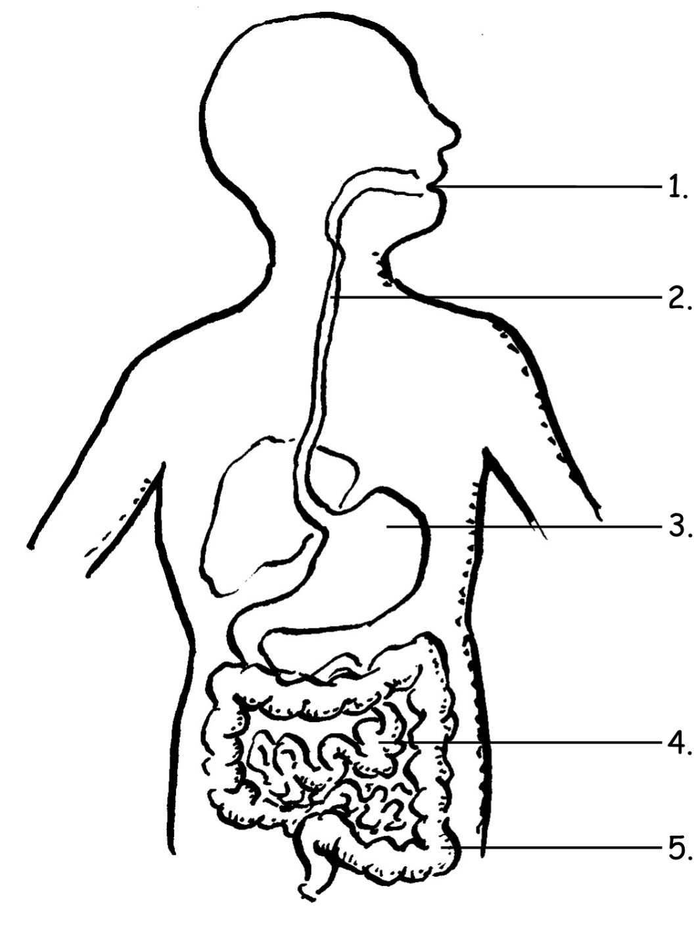](https://www.google.com/url?sa=i&rct=j&q=&esrc=s&source=images&cd=&cad=rja&uact=8&ved=0ahUKEwj44NzjkpLZAhUCh7wKHX1ZCu8QjRwIBw&url=https://anatomyinnerbody.com/human-digestive-system-drawing-and-labelling/human-digestive-system-drawing-and-labelling-digestive-system-diagram-for-kids-choice-image-human-anatomy-image/&psig=AOvVaw3Niq44zQfpWVp1ZQMwLdHa&ust=1518035828832973)