GETTING URGENT HELP
If an emergency arises and you need help in a crisis, you should turn to :
Emergency Services | 111
Emergency Mental Health | 0800 112 334
Community Mental Health
Napier | 06 878 8109 ext 4220
Hastings | 06 878 8109 ext 5700
Wairoa | 06 838 7099 ext 4875
CHB | 06 858 9090 ext 5551
Child, Adolescent & Family Mental Health Services | 06 878 8109 ext 5848
Directions Youth Health centre | 06 871 5307
Depression www.depression .org.nz | 0800 111 757 (24 /7)
Lifeline | 0800 543 354 (24/7)  Free txt 5626
Kidsline | 080054 37 54
Suicide Prevention Tautoko | 0508 828 865
Samaritans | 0800 726 666
What’s Up | 0800 942 8787
Youthline | 0800 376 633  Free txt 234
Mental Health Foundation of NZ | www.mentalhealth.org.nz
Commonground | www.commonground.org.nz
The Lowdown | www.thelowdown.co.nz
Sparx | www.sprx.org.nz
Suicide Prevention Information NZ | www.spinz.org.nz
Birthright | http://www.birthrighthb.org.nz  Napier: 0800 457 146. Tel (06) 835 2162  Hastings: 0800 457 146 Tel: (06) 873 3666
Napier Family Centre | http://www.napierfamilycentre.org.nz/  06 843 7280
Family Works | https://familyworks.org.nz/  06-876 2156

A Resource Kit for Schools from the Ministry of Education
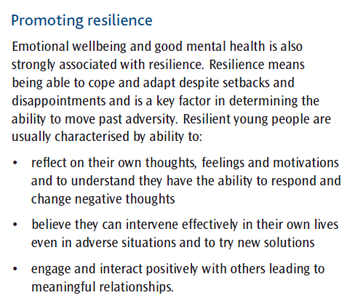
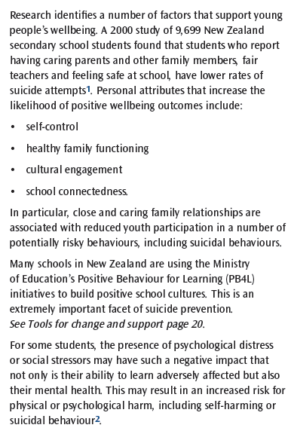
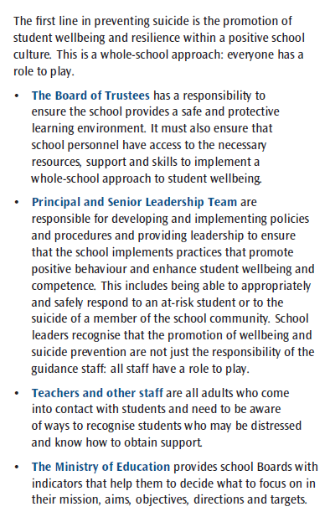

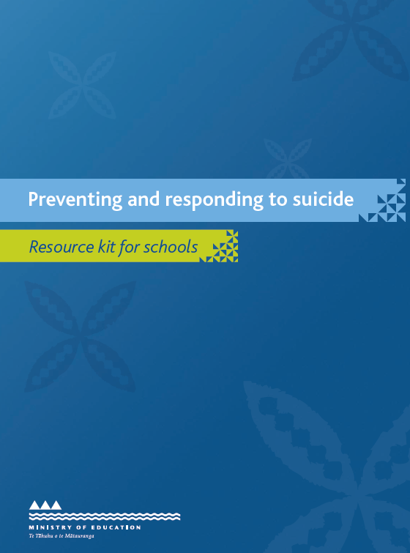
For copies of this resource:
