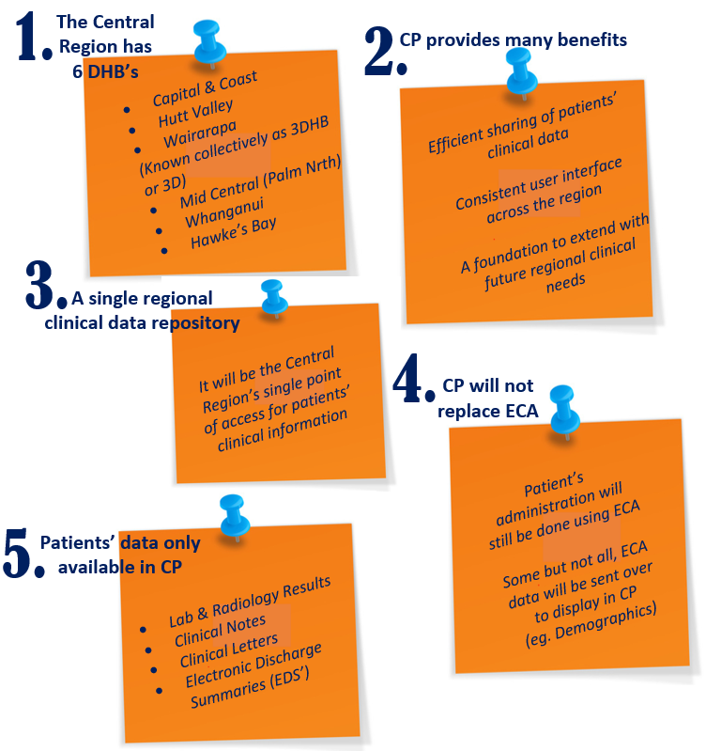
V1. 18-5-18

Login Page:
Select Hawke’s Bay DHB from the Organisation drop down box, then login using your network credentials.
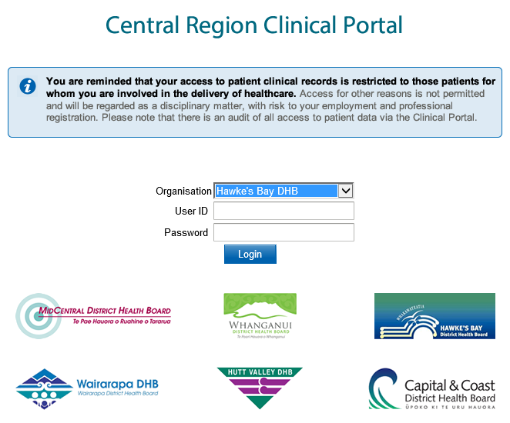
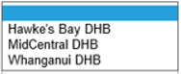

Homepage & User Settings:
Create worklists for groups of patients you wish to keep track of. Worklists can be renamed and added to your homepage if desired.

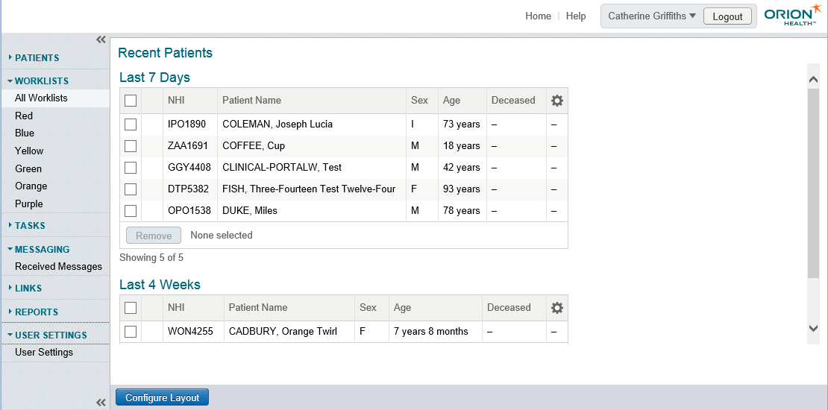
View messages sent from your system administrator (IT)
Configure your homepage display. Add/remove windowlets where you prefer.

Personalise your user settings to best suit your workflow. Align yourself to a ward, clinician etc.

Patient Search & List:
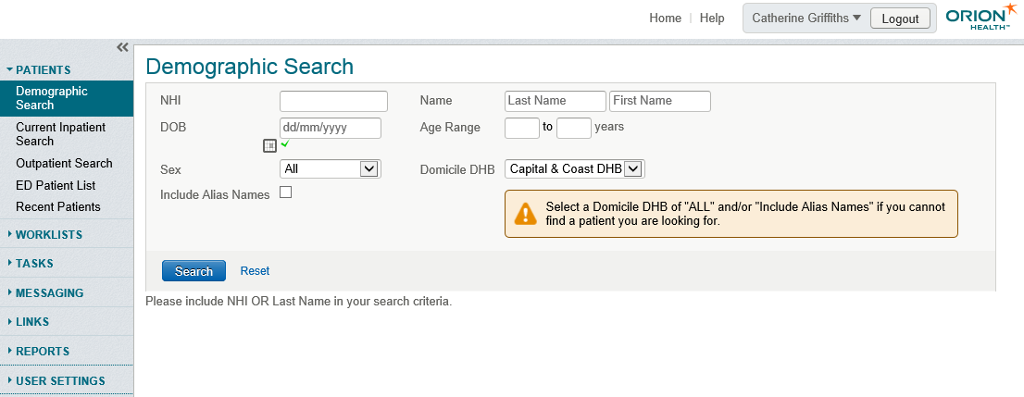

There are several ways of searching for a patient:
- Demographic Search – Use patients NHI, Name and/or date of birth to search.
- Current Inpatient Search – Generate a list of current inpatients. You can filter by Clinician, Facility, Speciality or Location.
- Outpatient Search - Generate a list of outpatients. You can filter by Clinician, Clinic, Speciality, DHB & date.
- ED Patient List – Shows all patients that are or have been in ED today.
- Recent Patients – The Recent Patients list is automatically populated with the names of the last 50 patients you have viewed.

Patient in Context & Overview:
Once you have selected a patient record you will see the screen below:
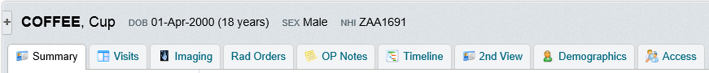
All activity is displayed in clean, clearly labelled tabs and holds different functionality:
- Summary – Displays alerts, CDV Tree and access summary (last five people to access the patient record)
- Visits – Shows current visit, visit history and any radiology orders
- Imaging – Allows you to search for any images against the patient
- Rad Orders – Used for ordering radiology against an encounter
- OP notes – Displays any outpatient notes recorded against the patient
- MH IP Notes – Displays notes relating to Mental Health admissions
- Timeline – A graphic representation of the clinical record
- 2nd View – Opens a duplicate of patient record in a new window
- Demographics – Patient contact details
- Unapproved Docs – Transcribed documents pending approval
- Access – Displays access history – anyone who has accessed the patient record in the last 30 days

Clinical Document Viewer aka CDV Tree:
The CDV Tree holds all clinical correspondence, documents and results:

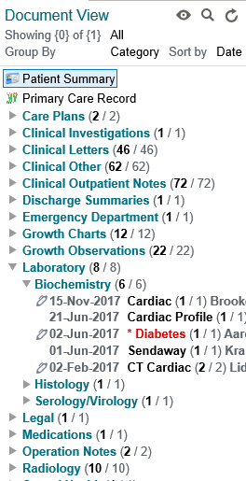
Takes you back to the original layout

Search the CDV Tree

Choose how you wish to view information in the CDV Tree:
Show: All, or specific range
Group By: Category, Date, Service or Author
Sort By: Date, Title or Author

Bold, red font indicates an abnormal result.
Pen icon indicates unsigned results.
Document count shows overall number of documents. Bold indicates amount of unread documents.

More Information:
If you have any questions please email clinicalportal@hawkesbaydhb.govt.nz, we are more than happy to help.
Visit the Clinical Portal homepage on Our Hub under Our Place

