View Only User Guide

Author: CP Training Team
Title: Regional Clinical Portal View Only User Guide
Organisation: HBDHB
Date: 15 June 2018
Document Version: 1.0

Contents
Login 3
Homepage 3
Patient Searches & Lists 4
Patient Summary Tab 5
Clinical Document Viewer aka CDV Tree 6
How to interpret the CDV Tree: 7
Visit Summary Tab 8
Imaging: Visual PACS Integration 8
Outpatient Notes 9
Mental Health Inpatient Notes 9
Unsigned Results 10
Timeline 11
Flowsheets 12
2nd View 13
Demographics 13
Access 13
Electronic Discharge Summaries 14
Worklists 15
User Settings 16

Privacy Note: All screenshots captured within this document have been taken within the Clinical Portal test environment and relate to fictitious patients and records

Login
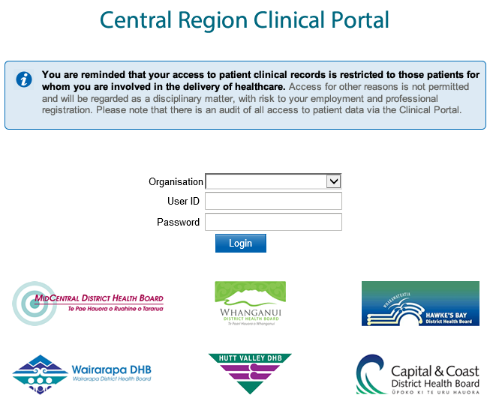
Select Hawke’s Bay DHB from the Organisation drop down menu then login using your network credentials. Your password will automatically update when your network password is changed.
Note: You can only log into one Clinical Portal session at a time. You must log out when you have finished a session.

Homepage

Once you have logged into Clinical Portal you will be presented with your homepage:
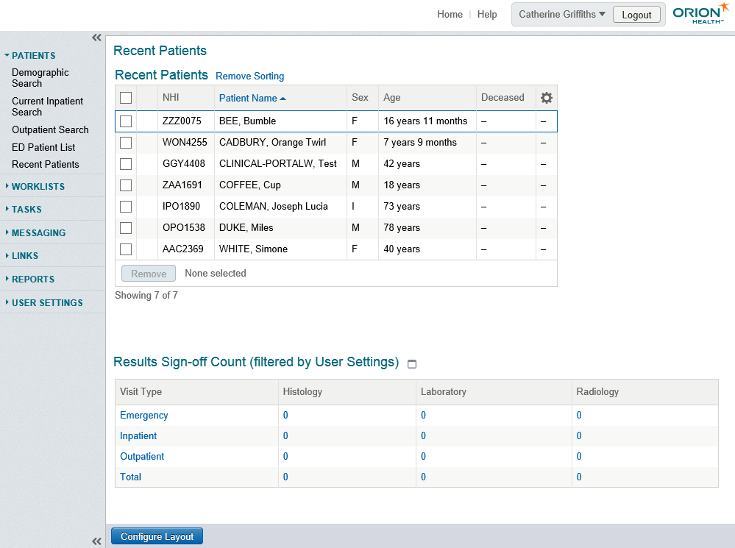

You can change the configuration of your homepage by clicking the Configure Layout button at the bottom of the page. Choose to display any preferred tables of information, in any order you want to see them.

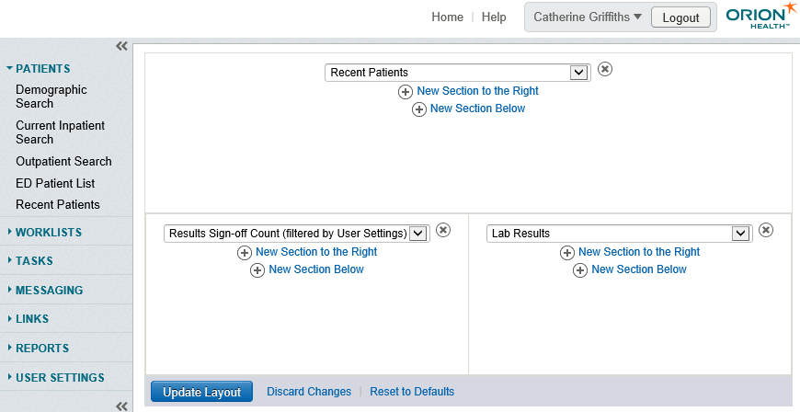

Patient Searches & Lists
To search for a patient, you can select options under Patients in the menu located on the left-hand side of your homepage:

There are several ways of searching for a patient:

- Demographic Search – Use patients NHI, Name and/or date of birth to search.
- Current Inpatient Search – Generate a list of current inpatients. You can filter by Clinician, Facility, Speciality or Location.
- Outpatient Search - Generate a list of outpatients. You can filter by Clinician, Clinic, Speciality, DHB & date.
- ED Patient List – Shows all patients that are or have been in ED today.
- Recent Patients – The Recent Patients list is automatically populated with the names of the last 50 patients you have viewed.

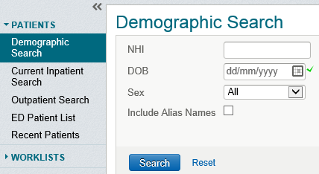

Favourite Searches can be created in both Current Inpatient and Outpatient Searches. Enter a name for the search, then click

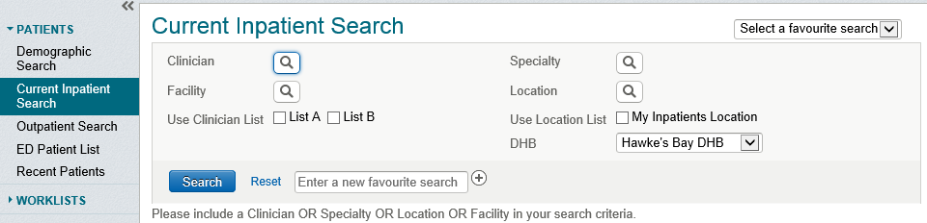

Selecting a patient from any list or search will open the patient’s record. In the example below you will see a number of tabs containing clinical information. Your access may differ depending on the level of access associated with your role, which will affect the tabs that you see.
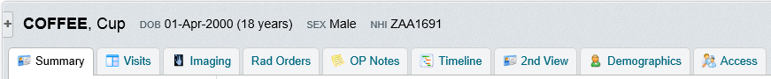
All activity is displayed in clean, clearly labelled tabs and holds different functionality:
- Summary – Displays alerts, CDV Tree and Patient Access Summary
- Visits – Shows current visit, visit history and any radiology orders
- Imaging – Allows you to search for any images against the patient
- Rad Orders – Used for ordering radiology against an encounter
- OP notes – Displays any outpatient notes recorded against the patient
- MH IP Notes – Displays notes relating to Mental Health admissions
- Timeline – A graphic representation of the clinical record
- Flowsheets – Displays preconfigured laboratory result profiles e.g. Common Bloods, Diabetes, and Renal.
- 2nd View – Opens a duplicate of patient record in a new window
- Demographics – Displays patient contact details
- Unapproved Docs – Transcribed documents pending approval
- Access – Displays access history – anyone who has accessed the patient record in the last 30 days

More information on each of these tabs is provided in the following pages

Viewing Patient Information

Patient Summary Tab
Selecting a patient from any patient search, worklist or recent patient list will open the patient’s record and default to the Patient Summary tab. The windowlets displayed in the Patient Summary tab are:
- Patient Access Summary: Displays the user currently logged in and the last five users to have assessed the patient record. A more detailed history is available in the Access tab (see page 14)
- Alerts: Local alerts are sourced from webPAS when available.
- NHI Medical Warnings: Information appearing in this panel is automatically retrieved from the Ministry of Health and relates to adverse medical reactions and significant medical conditions. The data displayed is read only and can only be updated at the source. If there are no medical warnings associated with a patient’s record a message stating this will appear.

See screenshot over page

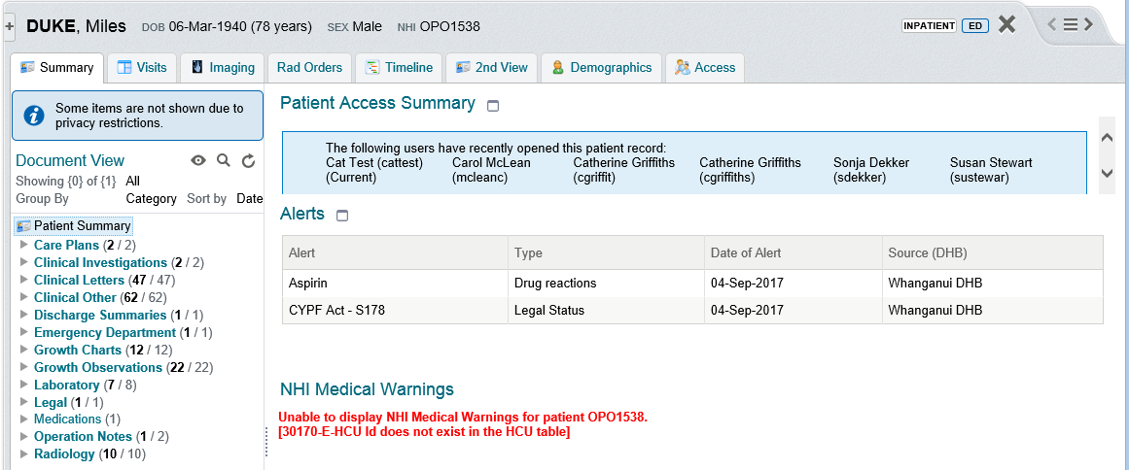

Clinical Document Viewer aka CDV Tree

The CDV Tree is displayed in the Summary tab and provides a list of a patient’s documents. The CDV Tree is categorised in folders that allow users to have direct access to information such as discharge summaries, clinical letters, laboratory results and radiology results from across the central region.

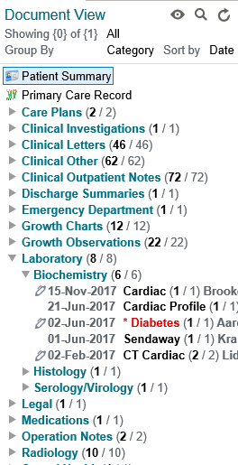

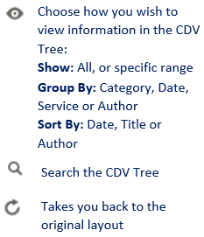
Document count shows overall number of documents. Bold indicates amount of unread documents.

Pen icon indicates unsigned results.

A worklist is a collection of patients put together to make it easier to find and work with patient records. You can create up to six worklists and rename as required. Worklists are created from the left-hand menu of your homepage and can also be viewed from here or added to your homepage if preferred.
Choose to access these from the let

Bold, red font indicates an abnormal result.

How to interpret the CDV Tree:

Item | Item | Style | Example
Documents | Read/Unread document count | (xx unread/xx total results)
 | Interim document | Italics
 | Final document (unread) | Bold font
 | Final document (read) | Normal font
Lab reports | Interim lab report | Item name in Italics
 | Final lab report (read) | Normal font
 | Abnormal lab report (unread) | Report name in red font bold, date and author in light grey bold.  One asterisk before report name
 | Abnormal lab report (read) | Report name in red font, date, author in light grey.  One asterisk before report name
Interpreting lab report | Unread | Report name in blue font, date and author in light grey
 | Read | Report name in blue font, date and author in light grey
 | Abnormal | Report name in red font, date and author in light grey.  One asterisk before report name

Visit Summary Tab
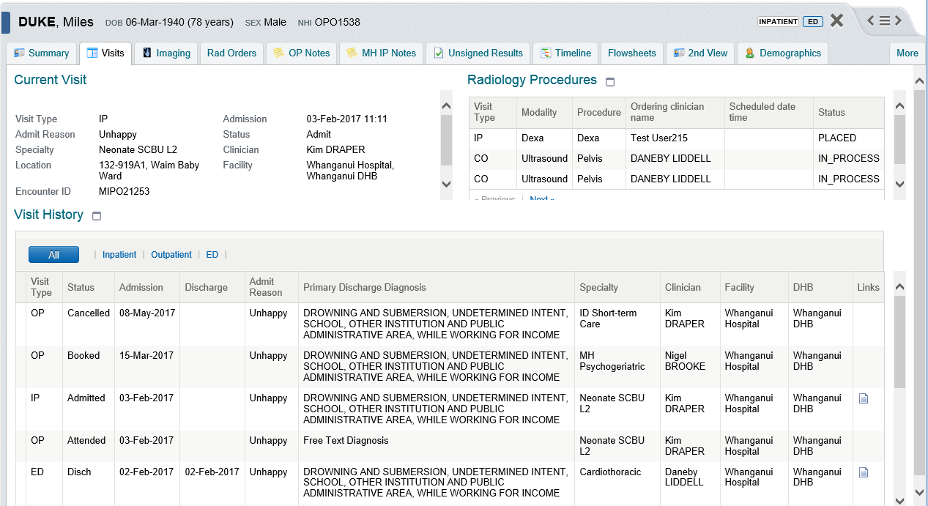

The Visit Summary tab shows the following windowlets:
Current Visit: The label in the patient banner displays the type of visit shown in the current visit window. The information in this window displays the details available in webPAS.
Radiology Procedures: Displays all scheduled or completed radiology procedures.
Visit History: The visit history table includes inpatient, outpatient and emergency department visits. By default all visits will show in one combined table, but you can filter by Inpatient, Outpatient and ED by clicking the column header. Note: Upon go-live, there will also be a Referrals filter available.

Imaging: Visual PACS Integration

There are two ways of that an authorised user can access radiology images within Clinical Portal:
- With a patient in context in Clinical Portal, a PACS Viewer entry point is invoked when the clinician clicks on the Imaging tab.
- You can also navigate to radiology images from a link on the radiology report page.
Note: HBDHB PACS has not been integrated with Central Region Clinical Portal as yet, so when you click on the imaging tab you will receive a ‘page cannot be displayed’ message.

Please Note: This section is for informational purposes only. Due to the limitations of View Only access, OP Notes tab will not display, but notes can be viewed from the CDV Tree in the Summary tab.

Also Note: Currently only Whanganui are using this functionality.

Outpatient Notes can be viewed from the CDV tree or by clicking on the Outpatient Notes tab. There are many different search options within this tab to narrow down what you are looking for, such as date, author, discipline, service and note type.
The intention of the Outpatient Note is to record outpatient and community progress information only. The Outpatient Notes function is not to be used for Inpatient or Emergency Department events.
There are many purposes:
- Record an interaction with a patient (clinical visit, phone call, etc.)
- Document a communication with another person, about a patient (phone call with GP)
- Record a treatment or management plan.
- Document a clinical decision.

Outpatient Notes

Mental Health Inpatient Notes
Please Note: This section is for informational purposes only. Due to the limitations of View Only access, MH IP Notes tab will not display, but notes can be viewed from the CDV Tree in the Summary tab.

Also Note: Currently only Whanganui are using this functionality.

The intention of the Inpatient Note is to record information relevant to the current inpatient event only.
Version 1 of IP Notes has been tailored to support the Mental Health Services only. To this end the tab has been called MH IP Notes and when selecting a visit (event/encounter) only encounters associated with Mental Health Services are presented for selection.
All users can see a list of IP Notes items in the CDV tree on the Patient Summary tab. When the CDV tree is in Category view these are displayed under Inpatient Notes. There is only one entry for each admission under the admission date. You can also view MH IP Notes by clicking on the MH IP Notes tab. There are search options within this tab to narrow down what you are looking for.

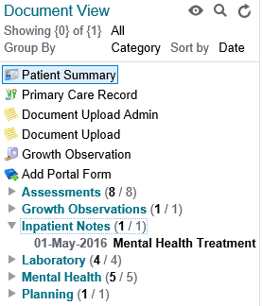
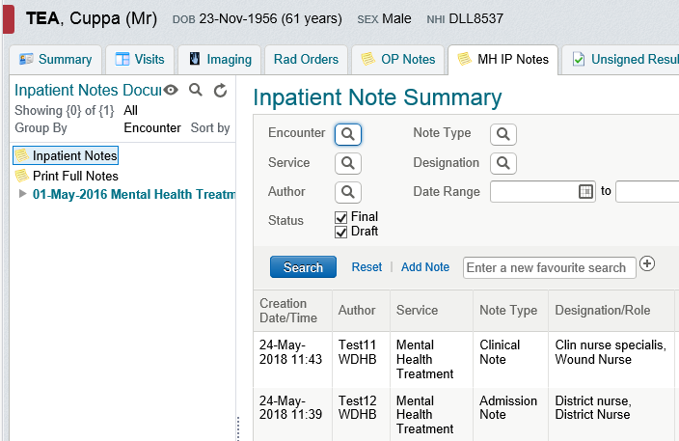

Unsigned Results
Please Note: This section is for informational purposes only. Due to the limitations of View Only access, the Unsigned Results tab will not display, but results can be viewed from the CDV Tree in the Summary tab. Refer to the table on page 7 (how to interpret the CDV Tree) to see what stage the results are at.

As a clinician, you are required to ‘close the loop’ on any investigations requested:
When ‘signing off’ a result you are ‘electronically verifying that you’ve taken the necessary action/s demanded by the result’. You can make comments in the comment box such as ‘chest x-ray ordered’, referral letter sent etc.
Results requiring sign off will have a pencil next to them.
To sign off a single result in the patient record, in the CDV tree (in Summary tab) click to display the single result you want to sign off. Locate the Report History section towards the end of the result, enter a brief note if applicable and then click the sign off button.
To sign off a single result in cumulative view, in the CDV tree click to display the single result you want to sign off, then click Cumulative view. In the Signed row, click the Sign-off icon in the column containing the result you want to sign off. The Sign-off screen displays. Enter a brief note in the Comment field if applicable and click the Sign-off button.
To sign off a single result in Flow Sheet view, in the patient record, click the Flowsheets tab, and select the flow sheet you wish to view Click the Sign-off icon in the column containing the result you want to sign off. The associated result is displayed. Locate the Report History section towards the end of the result. Enter a brief note in the Comment field if applicable and click the Sign-off button. To return to the Flow Sheet, click the Laboratory Results Flow Sheet link.
Only the clinician who originally signed off a result can revert that sign off. When you have completed a sign off, a new entry is added to the top of the Report History. To revert a sign off locate the Report History section towards the end of the result. Select the Revert Sign-Off link in blue. Specify a reason for reverting the sign off and then click the Revert Sign-off button.

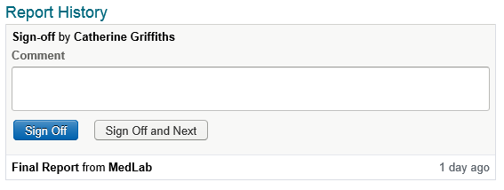

Timeline

The Timeline View displays the following categories of data:
- Visits: Inpatient, Outpatient and Emergency
- Documents in the CDV tree (including diagnostic results)
- Orders Summary (Radiology). Please note that if more than one order has been placed on one day, only the first order made on the day will display.

You can interact with timeline views in the following ways:
- View the detail of an individual item in the Timeline by hovering your mouse over the relevant link.

- Zoom in on a selected time frame. Use your mouse to click and drag to zoom in on a selected time frame. The area you have highlighted will display in blue. Click Reset Zoom to return to the full Timeline View.

- Open Documents directly from the Timeline. Opening a document from the Timeline will not mark it as read in the CDV Tree.

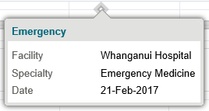

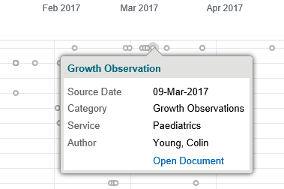

Flowsheets
Please Note: This section is for informational purposes only. Due to the limitations of View Only access, Flowsheets tab will not display, but laboratory results can be viewed from the CDV Tree in the Summary tab.

A flowsheet is a tabulated summary of recent laboratory results (in chronological order, with the most recent first). These results can also be displayed in a graph. Eight flowsheets are available:
- Common Bloods
- Cardiac
- Chemistry
- Diabetes
- Haematology
- Hormone
- Infection
- Renal
To view Flowsheets, with patient in context, click the Flowsheets tab:

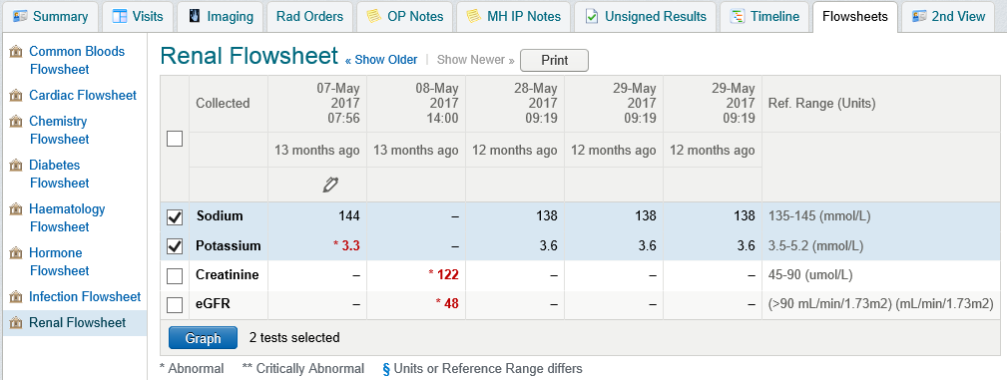

- The last 5 results are available by default, but older results can be opened.
- Flowsheets only displays lines with results available. If no results have been received for an item for this patient then the item will not display.
- Select collected items and click Graph if you prefer to view this way.

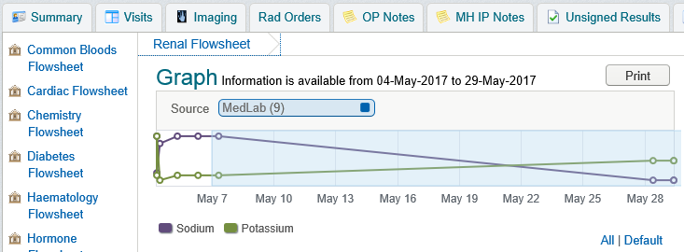

2nd View

You cannot have two instances of Clinical Portal open at one time, unless you are within a patient’s record. With patient in context, click the 2nd View tab which will open up an additional window. This may be helpful for viewing results whilst typing notes, for example. As soon as you close the patient’s record or navigate to a different patient record using the buttons, both windows will close. This is a patient safety feature.

Demographics
The information displayed in the Patient Demographics tab is live fed into Clinical Portal from PAS. This information will continue to be visible and updated in PAS.

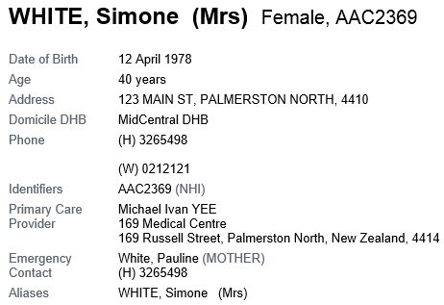

Access Tab
The Access tab displays a list of users who have accessed the patient’s record within the last 30 days. Each users name is only added once each day they access the record:
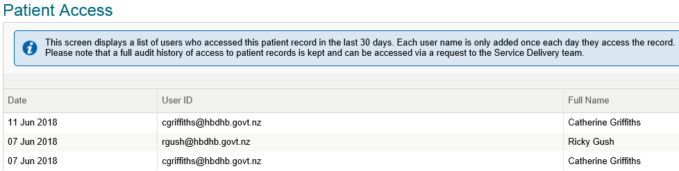

Electronic Discharge Summaries

Please Note: This section is for informational purposes only. All existing discharge summaries will display in the CDV Tree, the table on page 7 will help you identify the stage discharge summaries are at.

Four Discharge Summary templates are available in Clinical Portal. These are:
- Adult Discharge Summary
- Paediatric Discharge Summary
- Deceased Summary
- Emergency Department Summary

A list of all documents already created will display, as well as the template link. To create a new discharge summary go to the Visits tab in the patient record. Under the Visit History section click the document icon under Links in the far right hand column.
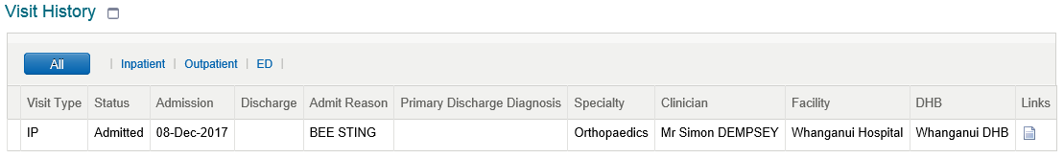
This page will then display:
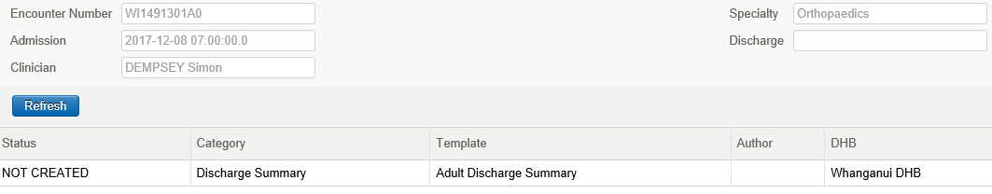
Click NOT CREATED to load the patient’s details into the default discharge summary template for this visit type.
- When creating a new document, the discharge summary that opens depends on the visit type and specialty of the visit, e.g. If a patient has an ED visit then the ED Summary will be presented.
- If you want to change the template type, click the name of the currently selected template. This is located under the document title. A warning message will display. Click OK to proceed. The TemplateChooser window displays, providing more details of the consequences of changing templates. If you still wish to use a different template type, click one of the available links to select, or click Close to return to the previous template without saving.

After you have populated the Discharge Summary you can choose to save as a draft or finalise. When a Discharge Summary is finalised it will immediately be sent to the patient’s GP and to any other selected external recipients you chose. If you wish to add a CC to the electronic discharge summary document you need to do this before you finalise the document.

To send a copy of the document to another clinician, that clinician must:
- Be linked with a clinic in WebPAS, and
- Have an associated clinic email address entered in WebPAS.

Worklists

Worklists make it easier to keep track of groups of patients. Each user has access to six worklists which are named by colours by default and can be renamed as required. Worklists can be created and viewed from the left-hand menu of your home screen or added to your homepage for quick access.
You can add a patient to a worklist when viewing in context:
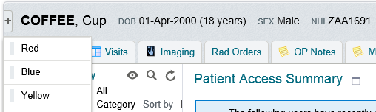

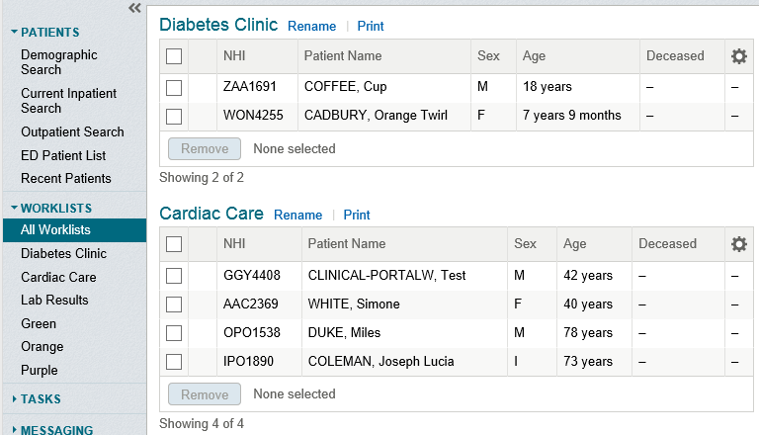

- Change the columns in your worklist table by selecting the settings symbol on the right of each list
- A printed worklist gives you an additional notes column at the far right hand side

Ensure to click 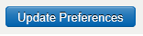 after changing any user settings.

User Settings

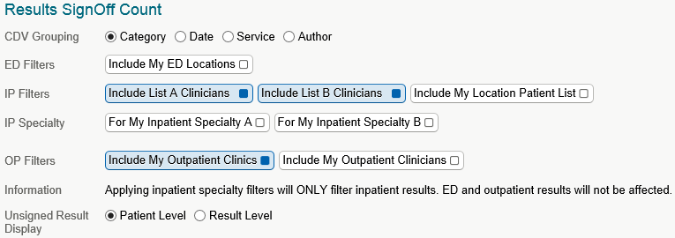
User Settings can be assessed from the left-hand menu of your home screen or from any other screen by clicking on your name on the top right-hand corner:

Inactivity Logout: Choose how long you want Clinical Portal to remain open before it automatically logs you out due to inactivity. Those using shared computers should consider setting this for a short time. The default is 1 hour.
Important Messages: Choose how you want to see alerts for messages from the System Administrators. The options are; until you dismiss it, for a selected amount of time or do not display alert at all.
Clinician Homepage: Set filters on information so you only see what you choose to see on your Homepage. Talk to you area Super User about setting this up.
MedDocs User: Complete first and last name fields if you are a MedDocs user, otherwise leave blank.
NZCIS – Designation: This section must be completed as it enables you to write Inpatient and/or Outpatient notes.
NZCIS – DHB: Set to Hawke’s Bay DHB
NZCIS – General: Select a default view for CDV Tree Grouping on the Patient Summary tab. Choose to view results singularly or cumulatively by default. Add NZMC number (if applicable), otherwise leave blank.
NZCIS – Portal Forms: Choose to view All Portal Forms by default, or create a list of forms most relevant to you by clicking Add and selecting relevant forms.

Results SignOff Count: Set filters for how you want your Results SignOff to be displayed and which results you wish to see. Be very careful with this setting as it will only show you what you ask for and not necessarily all your results. Selecting My ED Location will show you all outstanding results for ED, which you wouldn’t want unless specifically working in ED.
