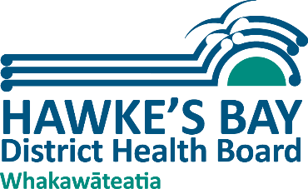
Health and Wellbeing for Learning

Ngā Kura Hauora

Supporting the wellbeing of the staff in schools

Many schools find that they want to look to the health & wellbeing of their staff as much as of their students. This is a brief list of some of the ways that local schools are working to promote the physical, mental, social and spiritual wellbeing of their staff.

- EAP schemes
- Staff pamper-days
- Healthy morning teas
- Staff social functions
- Flowers / support for celebrations / illnesses
- Rostered mental-health days
- Pre-planned relief lessons
- Interruption-free weeks
- Careful timeplanning of deadlines
- Teacher-aide support
- Smoking cessation support
- Gym membership / yoga
- Lunchtime walking group
- Mindfulness classes
- Professional supervision that is prioritised and budgeted
- Celebrations
- Recognition of successes
- POETS day
- Set up a staff wellbeing team

It can be useful to have a structure or framework to give careful thought to staff wellbeing.
The framework would ideally cover three levels within the workplace;
- Organisation (looking at goals, policies, procedures which support these activities and wellbeing of staff)
- Environment (what kind of environment do people work in are there adjustment that can be made to make the environment both physical, mental and emotional more support the wellbeing.
- Individual (opportunities for staff to learn about how to stay healthy and happy). Many of the initiatives below would fall under the individual level.
If you look at the WorkWell website they have good overview of the three levels. Here is the link http://www.workwell.health.nz/workwell_overview

There are many frameworks out there which can be used. A few of these are under the heading ‘Models to become healthy’ on the Wellplace website. Here is the link
http://wellplace.nz/facts-and-information/what-is-a-healthy-workplace/

You might like to look at https://www.good4work.nz/ which has been set up to support small employers with the health & wellbeing of their staff. There’s a short video to introduce the issues, then a quiz which will get you and your team thinking and set you on the path to some positive actions.

Websites to check, share and promote:

The core site for ideas and information is Wellplace:
http://wellplace.nz/
and at the bottom of that page you can sign up for the newsletter.

The year planner of events and themes is at:
http://wellplace.nz/resource-library/wellplace-planner-201718/
The cartoon video on healthy workplaces is at:
http://wellplace.nz/resource-library/what-is-a-healthy-workplace/
The access point to the information and quiz on Good4work is at:
https://www.good4work.nz/
There is advice on particular issues (eg mental health, alcohol, sunsmart etc) at:
http://wellplace.nz/facts-and-information/

The Ministry of Education also provides information & support for schools considering staff wellbeing at:
http://www.education.govt.nz/ministry-of-education/specific-initiatives/health-and-safety/staff-wellbeing/

