CHILD HEALTH TEAM
Ngā Kura Hauora

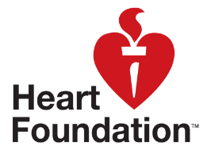

Ngā Kahikatea

Newsletter Messages September 2019
Each month we offer a selection of messages that you can copy / use / edit / re-style and include in your school newsletter or Facebook page. The idea is to support the work that you are doing in the classroom and on the playing field with positive messages that are going home.
In this issue, all our messages are related to the theme of HEALTHY SCHOOL LUNCHES.

Looking for lunchbox ideas? Try:
Kidspot: https://kidspot.co.nz/school-age/back-to-school/lunchbox/
Family Pantry: https://familypantry.nz/family-pantry-blog?journal_blog_post_id=68
Heart Foundation: https://www.heartfoundation.org.nz/wellbeing/healthy-recipes
Eat Well: https://www.eatwell.co.nz/hot-topics/wellbeing/2531/The-school-lunch-box/
Stuff: https://www.stuff.co.nz/taranaki-daily-news/news/108897100/tips-on-packing-a-healthy-lunch-box
And a word of warning… many websites show images of school lunches that are unrealistic. Be careful of websites that raise expectations and expect perfect presentation. A lunchbox needs to be nutritious, simple and affordable – it doesn’t have to be a work of art.

Some of the Recipes at “Fuelled for Life” http://www.fuelled4life.org.nz/recipes
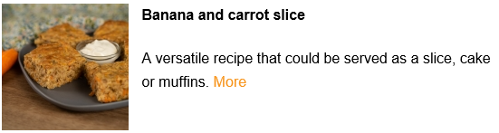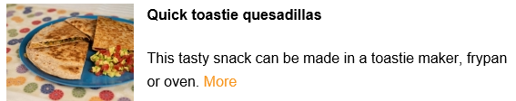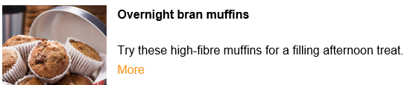

Newsletter Images for Healthy School lunches:
