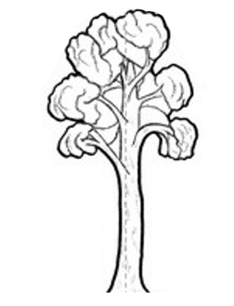
CHILD HEALTH TEAM
Ngā Kura Hauora

Ngā Kahikatea

Newsletter Messages October 2019
Each month we offer a selection of messages that you can copy / use / edit / re-style and include in your school newsletter or Facebook page. The idea is to support the work that you are doing in the classroom and on the playing field with positive messages that are going home.
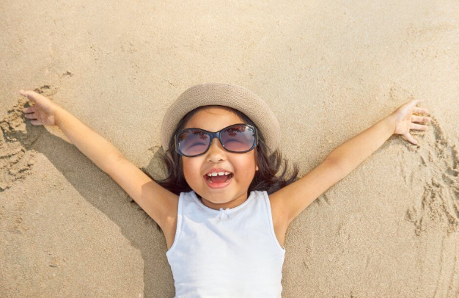
In this issue, all our messages are related to the theme of ACTIVE FUN IN THE SUN.

Here are a set of games and activities for active play at the beach or on the grass this summer. As well as being fun, they’ll help children develop their Fundamental Movement Skills.

How Low Can You Go?
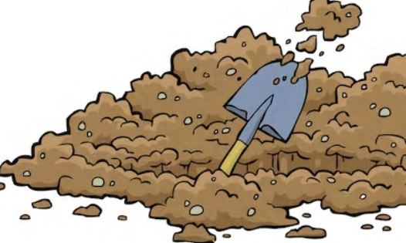
Nothing beats good-old digging in the sand. Get your kids to see how deep of a hole they can dig and when they’ve dug as far as they can, see if an adult can fit in the hole or see how long it takes to fill the hole with water. Please remember to fill in any holes you dig in the sand when you’re done playing for the safety of other people using the beach.
Required: shovels and varying levels of attention span
Skills developed: lifting and lowering objects

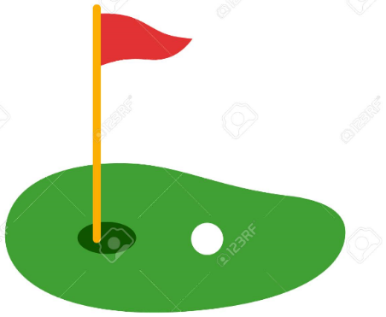
Mini Golf
Let your child bring out their inner Phil Mickelson and spend a day at the sandy links. Pick up a plastic set of clubs and balls at your local dollar store or improvise with what you have on hand at the beach. Set up a few targets to aim for or dig holes in the sand to practice your child’s short game.
Required: a set of clubs and balls Skills developed: striking, coordination

Beach Frisbee Golf
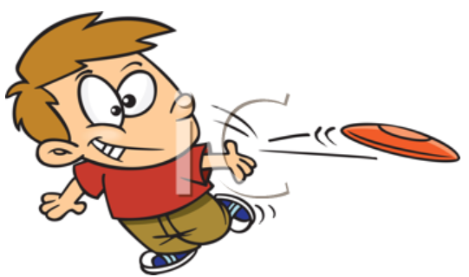
Substitute a plain old game of frisbee with frisbee golf. Set up targets using items you brought to the beach (could be a picnic blanket, an umbrella, a towel, or you could even dig a hole in the sand to aim at). Take turns trying to throw your frisbee as close to the target as you can. Make sure smaller kids are allowed to stand closer to the target than the bigger ones to keep frustration levels to a minimum.
Required: at least one frisbee Skills developed: throwing

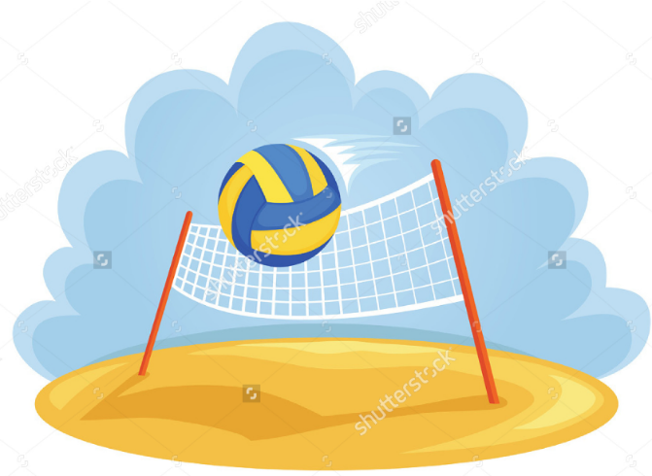
Beach Volleyball
Depending on the ages of the kids playing, a real volleyball and net can be set up. For the smaller set, a beach ball and a towel are great substitutes. Try to count the number of times you can get the ball back and forth.
Required: a ball (some beaches have nets set up)
Skills developed: volleying, throwing

Tug of War, Beach Style
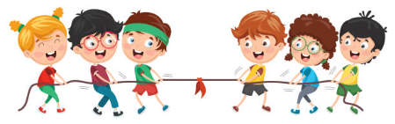
Using a skipping rope or towels tied together, stand at the water’s edge. Divide the kids (and adults) into two teams. Make sure the middle of the rope is right over a line drawn in the sand. Hand the ends of the rope to each team and show them how to pull. Be prepared to end up in the water!
Required: a skipping rope and strong muscles Skills developed: balance

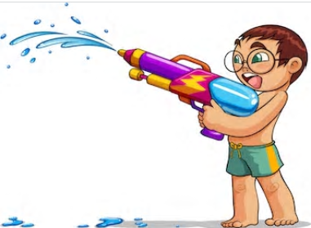
Squirt Ball
Kids can work together or compete against each other in this fun game. Give each child a beach ball and squirt gun or spray bottle and have them stand across a line drawn in the sand. Each child has to squirt their ball with all of their might to get it across another line down the beach. Run to the water’s edge to refill squirt guns if water runs out or to begin the game again.
Required: squirt guns and beach balls
Skills developed: hand/eye coordination

“Parachute” Games
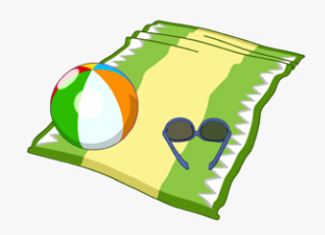
Kids love parachute games. Adults love parachute games. So grab a large beach towel and a beach ball, hold the ends and sides of the towel with the ball in the middle of the towel, and see how high that ball can bounce. Aim for the sky!
Required: a beach towel and beach ball
Skills developed: lifting and lowering, motor control of hands and arms

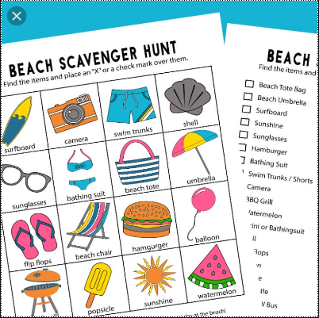
Beach Treasure Hunt
Supply each child with a list (can be a written list or a list with pictures) and a bucket in which they can collect their treasures. Have your kids hunt for driftwood, shells, rocks, crabs, something round, something blue, a feather, etc. The list can be as long or as short as you feel your child will be able to handle.
Required: a bucket in which to collect the treasures; a prepared list of items

- Stay in the shade from 10 - 4
- Wide brimmed hats protect the face, neck and ears
- Close fitting, wrap-around sunglasses protect your eyes from UV radiation
- Half a teaspoon of sunscreen to face, ears and neck
- One teaspoon of sunscreen to each arm and leg

