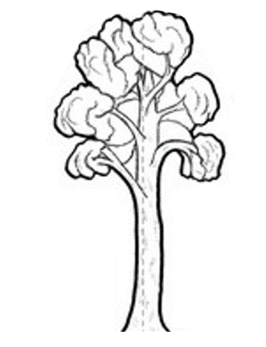
CHILD HEALTH TEAM
Ngā Kura Hauora

Ngā Kahikatea

Newsletter Messages May 2019
Each month we offer a selection of messages that you can copy / use / edit / re-style and include in your school newsletter. The idea is to support the work that you are doing in the classroom and on the playing field with positive messages that are going home.

Some of our classes have been learning about how their hearts work and how to measure their pulse rate. There’s a lot that you can do to look after your heart. Ask your child what they have been learning and listen to their ideas for good heart health.

Let’s play every day
‘Let’s play every day’ promotes the importance of active play for children by encouraging parents and whānau to play with their children – every day.
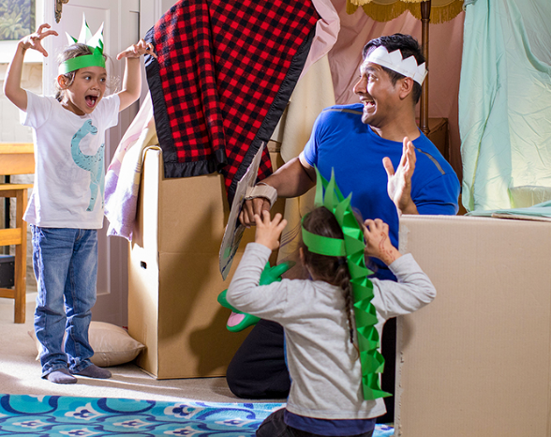
Here's some top tips to get you started:
- Walk, run and play with your children. By being active with them you are setting a good example.
- If your children are not usually active, start with something fun like a trip to the local playground.
- Instead of short car trips, try walking, biking or scooting with your children.
- Encourage your children to play outside as much as possible.
- Try to do something fun and active as a family each week. Some ideas are rolling down a grass bank, playing tag, walking along the beach or taking a trip to your local pool.
- Limit the amount of time your children spend watching TV or in front of a screen to less than one hour per day.
Find out more at: https://www.healthykids.org.nz/move/articles
Do you know your Food Groups? And do your children know about them? We’ve been learning about food & nutrition, so ask your child to explain to you about the 5 essential food groups and what we need each group for. Ask your child why the diagram here isn’t divided up equally.

One in four New Zealanders catches flu each year.
Influenza, “the flu”, can be anywhere. It is easy to catch through coughs and sneezes. Influenza is much worse than a cold.
Some people are more likely to get very sick when they have the flu. They are young children, babies, pregnant women and older people. Also, people with some illnesses like asthma or diabetes.
Some people with flu need to stay in hospital for a while. A few people die from flu.
Many people don’t know they have had the flu as they do not feel ill. But they can still pass it on and make other people very sick.
The best way to protect yourself is by having a flu shot every year. The flu shot helps your body protect itself from flu.
You protect yourself, your family and people around you if you have a flu shot.
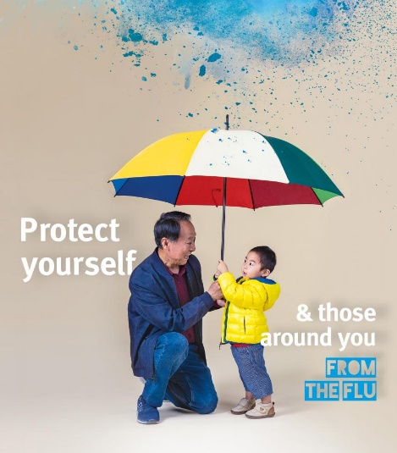
Flu shots are FREE for people 65 years old and over.
Flu shots are FREE for women who are pregnant.
Flu shots are FREE for anybody under 65 with diabetes, most heart or lung conditions and some other illnesses.
A flu shot is FREE for children under 5 who have had a stay in hospital for asthma or other breathing problems.
Ask your doctor or nurse about a flu shot today. It may be FREE for you.
Encourage your whanau who can get a free flu shot to see their doctor or nurse.
Being fit and healthy won’t stop you getting the flu.
You can’t get flu from the vaccine.
You need to get a flu shot every year before winter for best protection.

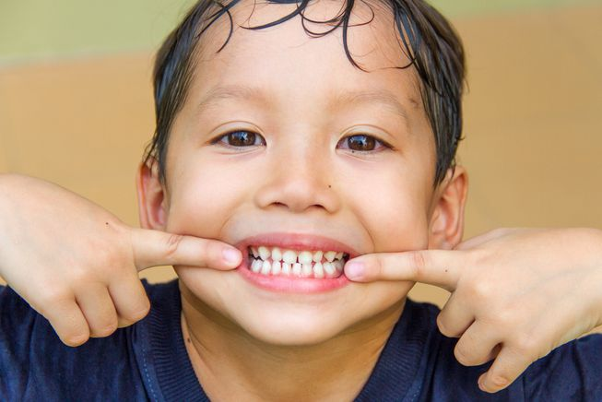
We are seeing some children at school with problems with their teeth; sometimes children are in pain or need some attention. There’s a lot that you can do to keep your child’s teeth in good condition: reduce the amount of sugar that they eat (and especially fizzy drinks), avoid snacking between meals, brush and floss twice a day (every day). If you are concerned, you can make an appointment for your child to see the Public Health Nurse.

At this time of year, many of our students are getting into their winter sports – rugby, netball, soccer etcetera. Parents can support children by
- Ensuring that they have their sports gear clean & ready
- Working with school and with other families to share transport to games
- Providing kids with a bottle of clean fresh water for re-hydration
- Encouraging them to participate – whatever the weather
- Praising them for giving it a go – whatever the result!

“Ngā Kahikatea” – a tree endemic to NZ that was previously widespread on the Heretaunga Plains. The tree is associated with concepts of standing tall and straight whilst mutually supporting one another at the roots. Like our tamariki in their communities and schools.

