Reading the Nutrition Labels
Earlier this week I was listening to a presentation by a nutritionist who was discussing the nutrition information labels on food packaging.
One of the comments she made suggested that we should look at the “per 100g” figure so that we can compare one product with another.
The following information arises from an activity that I used to do with Year 10 Science classes and challenges that idea; in fact it is the “per serve” numbers that we should concentrate on.

Sometimes, for lunch I like to have something tasty on toast. Looking in the kitchen cupboard I see that I could opt for Vegemite or Baked Beans.
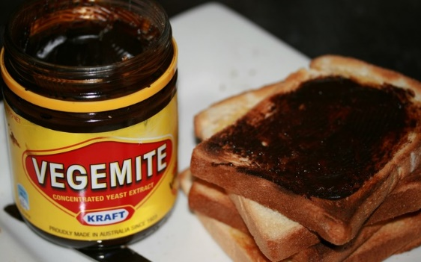
I notice on the label of the Vegemite that there is 3300mg of sodium (read “salt”) per 100g. That’s a very high number and confirms what my taste buds tell me – that vegemite is a salty food. The label goes on to say that a serving (in this case 5g – what I would spread on my toast) contains 165mg of sodium. I can’t easily relate to that number but the manufacturer has helped by pointing out that this is 7% of my RDI. So I’ll be getting 7% of my daily salt needs from my vegemite on toast.
A quick calculation shows that the RDI for sodium is around 2350mg.
So, recognising that too much salt will be bad for my blood pressure I look at the Baked Beans instead. I’ve chosen “lite” beans which are advertised as low salt and low sugar. They’re the healthy choice and score 4.5 stars on the Health Star system.
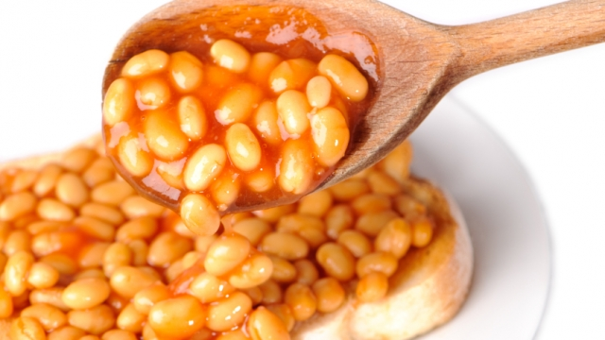
The nutrition label says the beans have 285mg of sodium (read salt) per 100 g which is a significantly smaller number than I saw on the Vegemite.
BUT, the portion size for beans is 210g – that’s how much I’d be putting on my toast and so (according to the panel) the beans have 600mg of sodium in a serving. Perhaps unsurprisingly, the label hasn’t converted that number to a percentage of my RDI, but since we know the RDI was 2350mg we can do the maths.
A serving of baked beans is providing me with about 25% of my daily salt requirement. There’s about 3.6 x as much salt in a serving of baked beans as there is in a serving of vegemite.

Enjoy your lunch – but read the nutrition panels with care!
John Adams March 2018

