Health and Physical Education

[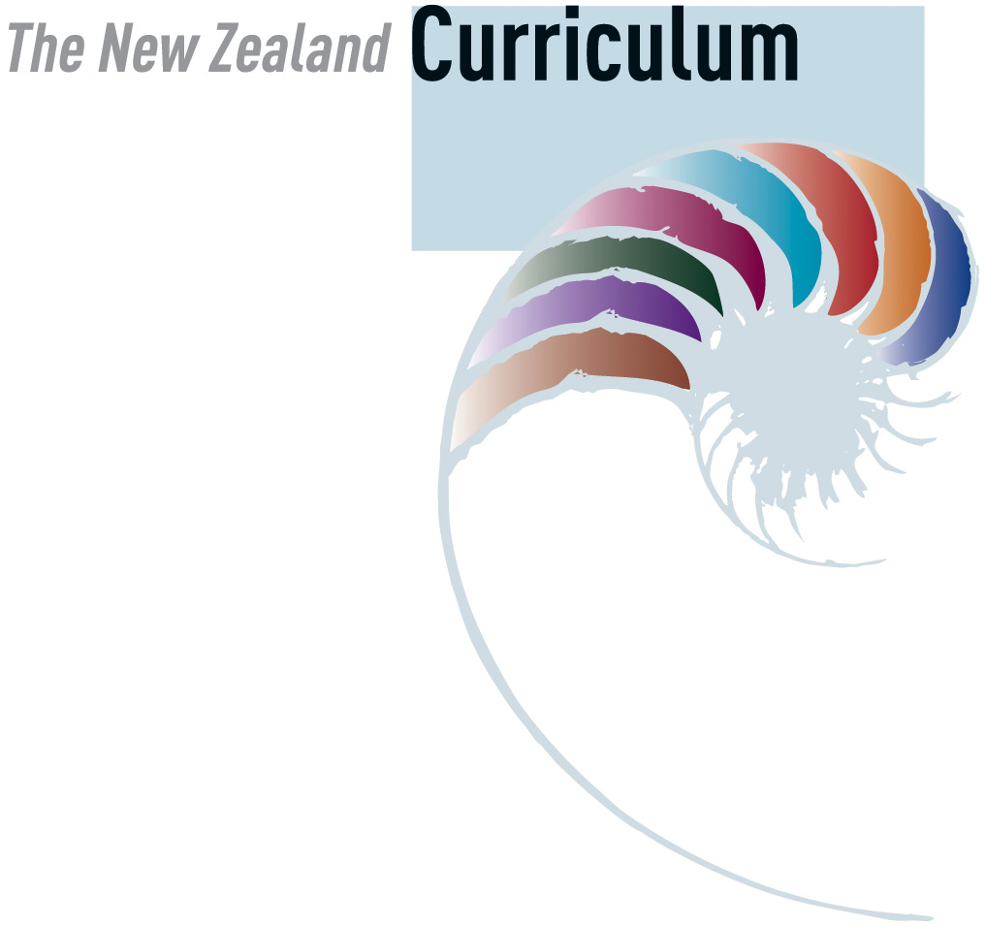](http://www.google.com/url?sa=i&rct=j&q=&esrc=s&source=images&cd=&cad=rja&uact=8&ved=0ahUKEwiYpPepmK_UAhUCErwKHRalDz0QjRwIBw&url=http%3A%2F%2Fwww.edgazette.govt.nz%2FArticles%2FArticle.aspx%3FArticleId%3D7905&psig=AFQjCNFgy7ifgQ-wrM9jfd4b5Fp0QDh_aA&ust=1497043636465815)

Level 1

Personal Health and Physical Development

Students will:

Personal growth and development

* Describe feelings and ask questions about their health, growth, development, and personal needs and wants.

Regular physical activity

* Participate in creative and regular physical activities and identify enjoyable experiences.

Safety management

[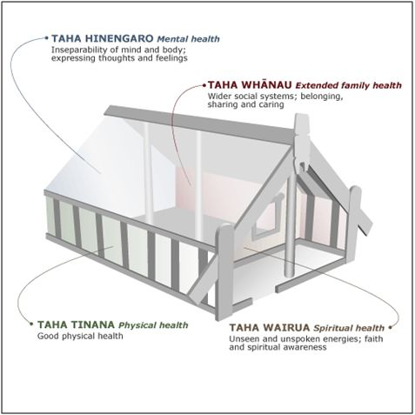](http://www.google.com/url?sa=i&rct=j&q=&esrc=s&source=images&cd=&cad=rja&uact=8&ved=0ahUKEwjo7pXSmK_UAhVTOrwKHbtKAnsQjRwIBw&url=http%3A%2F%2Florrainedodd.wixsite.com%2Florraine-dodd%2Fsingle-post%2F2015%2F07%2F29%2FMaori-model-for-Health-and-Wellbeing&psig=AFQjCNFgy7ifgQ-wrM9jfd4b5Fp0QDh_aA&ust=1497043636465815)

* Describe and use safe practices in a range of contexts and identify people who can help.

Personal identity

* Describe themselves in relation to a range of contexts.

Movement Concepts and Motor Skills

Students will:

Movement skills; Science and technology

* Develop a wide range of movement skills, using a variety of equipment and play environments.

Positive attitudes; Challenges and social and cultural factors

* Participate in a range of games and activities and identify the factors that make participation safe and enjoyable.

[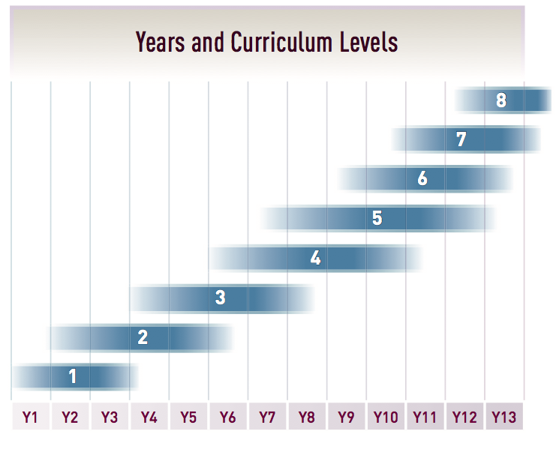](http://www.google.com/url?sa=i&rct=j&q=&esrc=s&source=images&cd=&cad=rja&uact=8&ved=0ahUKEwixlcGBma_UAhUKvbwKHSEvCiQQjRwIBw&url=http%3A%2F%2Fnzcurriculum.tki.org.nz%2FThe-New-Zealand-Curriculum&psig=AFQjCNFgy7ifgQ-wrM9jfd4b5Fp0QDh_aA&ust=1497043636465815)

Relationships with Other People

Students will:

Relationships

* Explore and share ideas about relationships with other people.

Identity, sensitivity, and respect

* Demonstrate respect through sharing and co-operation in groups.

Interpersonal skills

* Express their own ideas, needs, wants, and feelings clearly and listen to those of other people.

Healthy Communities and Environments

Students will:

Community resources

* Identify and discuss obvious hazards in their home, school, and local environment and adopt simple safety practices.

Rights, responsibilities, and laws; People and the environment

* Take individual and collective action to contribute to environments that can be enjoyed by all.

Level 2

Personal Health and Physical Development

Students will:

Personal growth and development

* Describe their stages of growth and their development needs and demonstrate increasing responsibility for self-care.

Regular physical activity

* Experience creative, regular, and enjoyable physical activities and describe the benefits to well-being.

Safety management

* Identify risk and use safe practices in a range of contexts.

Personal identity

* Identify personal qualities that contribute to a sense of self-worth.

Movement Concepts and Motor Skills

Students will:

Movement skills

* Practise movement skills and demonstrate the ability to link them in order to perform movement sequences.

Positive attitudes

* Participate in and create a variety of games and activities and discuss the enjoyment that these activities can bring to them and others.

Science and technology

* Use modified equipment in a range of contexts and identify how this enhances movement experiences.

Challenges and social and cultural factors

* Develop and apply rules and practices in games and activities to promote fair, safe, and culturally appropriate participation for all.

Relationships with Other People

Students will:

Relationships

* Identify and demonstrate ways of maintaining and enhancing relationships between individuals and within groups.

Identity, sensitivity, and respect

* Describe how individuals and groups share characteristics and are also unique.

Interpersonal skills

* Express their ideas, needs, wants, and feelings appropriately and listen sensitively to other people and affirm them.

Healthy Communities and Environments

Students will:

Societal attitudes and values

* Explore how people's attitudes, values, and actions contribute to healthy physical and social environments.

Community resources

* Identify and use local community resources and explain how these contribute to a healthy community.

Rights, responsibilities, and laws; People and the environment

* Contribute to and use simple guidelines and practices that promote physically and socially healthy classrooms, schools, and local environments.

Level 3

Personal Health and Physical Development

Students will:

Personal growth and development

* Identify factors that affect personal, physical, social, and emotional growth and develop skills to manage changes.

Regular physical activity

* Maintain regular participation in enjoyable physical activities in a range of environments and describe how these assist in the promotion of well-being.

Safety management

* Identify risks and their causes and describe safe practices to manage these.

Personal identity

* Describe how their own feelings, beliefs, and actions, and those of other people, contribute to their personal sense of self-worth.

Movement Concepts and Motor Skills

Students will:

Movement skills

* Develop more complex movement sequences and strategies in a range of situations.

Positive attitudes

* Develop movement skills in challenging situations and describe how these challenges impact on themselves and others.

Science and technology

* Participate in and describe how their body responds to regular and vigorous physical activity in a range of environments.

Challenges and social and cultural factors

* Participate in co-operative and competitive activities and describe how co-operation and competition can affect people’s behaviour and the quality of the experience.

Relationships with Other People

Students will:

Relationships

* Identify and compare ways of establishing relationships and managing changing relationships.

Identity, sensitivity, and respect

* Identify ways in which people discriminate and ways to act responsibly to support themselves and other people.

Interpersonal skills

* Identify the pressures that can influence interactions with other people and demonstrate basic assertiveness strategies to manage these.

Healthy Communities and Environments

Students will:

Societal attitudes and values

* Identify how health care and physical activity practices are influenced by community and environmental factors.

Community resources

* Participate in communal events and describe how such events enhance the well-being of the community.

Rights, responsibilities, and laws

* Research and describe current health and safety guidelines and practices in their school and take action to enhance their effectiveness.

People and the environment

* Plan and implement a programme to enhance an identified social or physical aspect of their classroom or school environment.

Level 4

Personal Health and Physical Development

Students will:

Personal growth and development

* Describe the characteristics of pubertal change and discuss positive adjustment strategies.

Regular physical activity

* Demonstrate an increasing sense of responsibility for incorporating regular and enjoyable physical activity into their personal lifestyle to enhance well-being.

Safety management

* Access and use information to make and action safe choices in a range of contexts.

Personal identity

* Describe how social messages and stereotypes, including those in the media, can affect feelings of self-worth.

Movement Concepts and Motor Skills

Students will:

Movement skills

* Demonstrate consistency and control of movement in a range of situations.

Positive attitudes

* Demonstrate willingness to accept challenges, learn new skills and strategies, and extend their abilities in movement-related activities.

Science and technology

* Experience and demonstrate how science, technology, and the environment influence the selection and use of equipment in a variety of settings.

Challenges and social and cultural factors

* Participate in and demonstrate an understanding of how social and cultural practices are expressed through movement.

Relationships with Other People

Students will:

Relationships

* Identify the effects of changing situations, roles, and responsibilities on relationships and describe appropriate responses.

Identity, sensitivity, and respect

* Recognise instances of discrimination and act responsibly to support their own rights and feelings and those of other people.

Interpersonal skills

* Describe and demonstrate a range of assertive communication skills and processes that enable them to interact appropriately with other people.

Healthy Communities and Environments

Students will:

Societal attitudes and values

* Investigate and describe lifestyle factors and media influences that contribute to the well-being of people in New Zealand.

Community resources

* Investigate and/or access a range of community resources that support well-being and evaluate the contribution made by each to the well-being of community members.

Rights, responsibilities, and laws; People and the environment

* Specify individual responsibilities and take collective action for the care and safety of other people in their school and in the wider community.

Level 5

Personal Health and Physical Development

Students will:

Personal growth and development

* Describe physical, social, emotional, and intellectual processes of growth and relate these to features of adolescent development and effective self-management strategies.

Regular physical activity

* Experience a range of personally enjoyable physical activities and describe how varying levels of involvement affect well-being and lifestyle balance.

Safety management

* Investigate and practise safety procedures and strategies to manage risk situations.

Personal identity

* Investigate and describe the ways in which individuals define their own identity and sense of self-worth and how this influences the ways in which they describe other people.

Movement Concepts and Motor Skills

Students will:

Movement skills

* Acquire and apply complex motor skills by using basic principles of motor learning.

Positive attitudes

* Develop skills and responsible attitudes in challenging physical situations.

Science and technology

* Investigate and experience ways in which scientific, technological, and environmental knowledge and resources assist in and influence people’s participation in regular physical activity.

Challenges and social and cultural factors

* Investigate and experience ways in which people’s physical competence and participation are influenced by social and cultural factors.

Relationships with Other People

Students will:

Relationships

* Identify issues associated with relationships and describe options to achieve positive outcomes.

Identity, sensitivity, and respect

* Demonstrate an understanding of how attitudes and values relating to difference influence their own safety and that of other people.

Interpersonal skills

* Demonstrate a range of interpersonal skills and processes that help them to make safe choices for themselves and other people in a variety of settings.

Healthy Communities and Environments

Students will:

Societal attitudes and values

* Investigate societal influences on the well-being of student communities.

Community resources

* Investigate community services that support and promote people’s well-being and take action to promote personal and group involvement.

Rights, responsibilities, and laws

* Identify the rights and responsibilities of consumers and use this information to evaluate health and recreational services and products in the community.

People and the environment

* Investigate and evaluate aspects of the school environment that affect people’s well-being and take action to enhance these aspects.