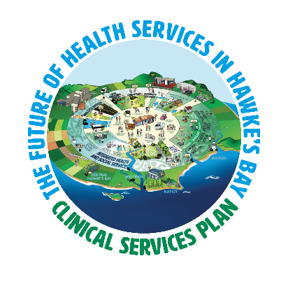

Why should I be interested in the Clinical Service Plan?
If you live in Hawke’s Bay, then you have a very important role in helping us to determine what our future health system should look like - what services will be delivered, how they will be delivered and where they will be delivered. Health affects everyone.

Why is the DHB undertaking this work now?
Future planning is important to sustain a growing population and a healthier Hawke’s Bay. Some of our models of care and facilities need to be replaced, revamped or expanded and to keep up with the growing demand on the health system in Hawke’s Bay. The Clinical Services Plan will help us to define what works well, what needs improvement and new opportunities to best meet our needs.

Does this just relate to hospital services?
No. This affects the whole Hawke’s Bay health system. General practice (doctor clinics) are the first part of the sector to contribute to the plan, as it is the place most people go to for health care.

Does this just affect clinicians?
No. A key part of this plan is gaining feedback from regular patients and consumers of health care, as well as the community at large. We all care about what health services look like and what’s available to us.

When will this work be complete?
We have scheduled for this to be signed off early next year. However, this is just the first step. Following the completion of the plan, we will move into scheduling the implementation over a ten year period.

Where can I find more information?
We will be updating information on www.ourhealthhb.nz or you can email clinicalservicesplan@hbdhb.govt.nz

Who’s putting the plan together?
Independent consultants, Sapere Research Group, are overseeing the project. Sapere has a good reputation in the health sector and has undertaken successful redesigns of other health systems. Because Sapere is independent, we hope feedback will be offered freely and frankly offering fresh and constructive viewpoints. You can read more about Sapere on their website http://www.srgexpert.com/

How can I be involved?
Sapere will be carrying out a number of workshops through until December 2017. Some people will be invited to attend specific workshops with a range of stakeholders from across the sector, including consumers of health services. Sapere will also be delivering presentations in November where you will have the opportunity to attend and have your say.

I have been invited to a workshop with Sapere, how can I prepare?
Sapere will do all of the work. They ask that you just bring along an open mind and a willingness to engage in some great discussions about the future. They may send out some pre-reading closer to the time.

How does this align with ‘The Big Listen’ that’s also happening around the same time?
Think of the Clinical Services Plan as the head and ‘The Big Listen’ as the heart. It is really opportune that these two pieces of work are being carried out at the same time. The outcomes of the Clinical Services Plan and ‘The Big Listen’ will be pulled to look very honestly at how we work together, ensuring staff have a vital role in designing and shaping a new and improved ‘us’.

